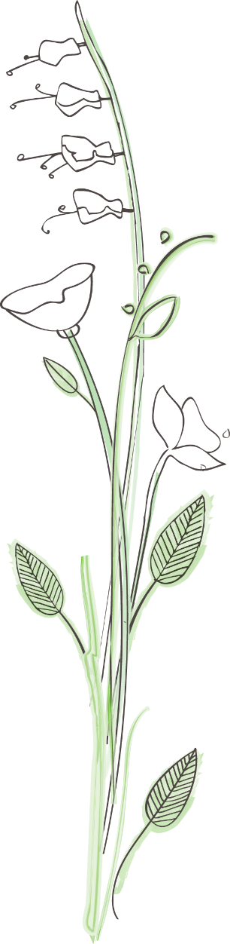
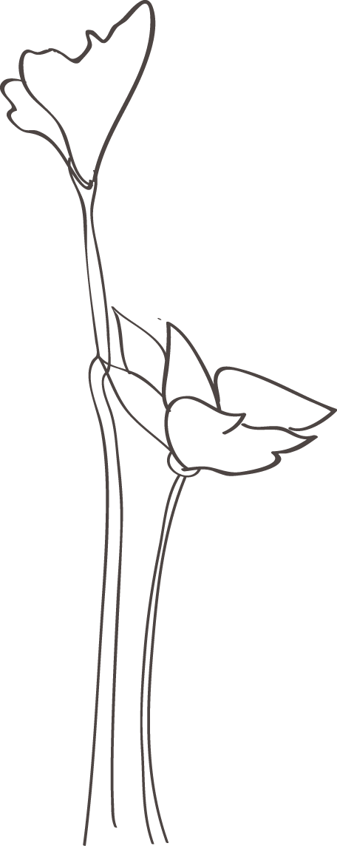
Lakeside Dockside Homeowners Association
Landscape Committee Checklist

Address of property: _________________________________________
Exterior of Town House: | Compliant | Non-Compliant
Mow grass, seed as needed, and use ground cover where applicable
Trim and/ or replace dead shrubs

Trim dead tree branches

Trim tree and shrubs to avoid blocking sidewalks
Remove trash and/or debris

Remove trashcans, trash bags, and/or recycling containers from the front yard
Repair or bury drain pipes

Townhouse Entrance:

Repair/ replace steps and sidewalk

Make house numbers visible from street

Repair/replace exterior light ﬁxture

Carport:

Replace/repair rotten wood

Paint structure

Replace/repair roof

Remarks:

Checked by _____________________ (Sign) On __________________(date)

